Reflection Report Project Website Development

Ricardo van der Heide 359861

City trips to the old cities of Europe

*A travel agency*

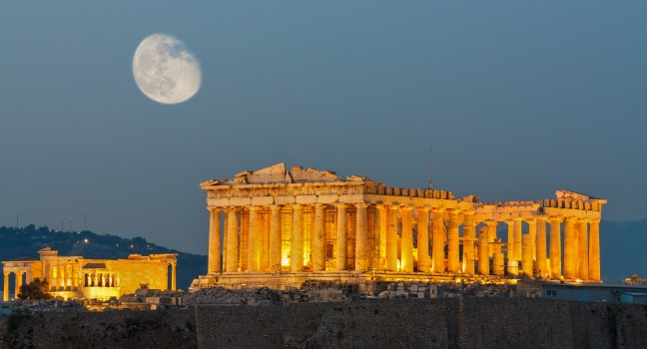

November 15th, 2016

R.A. van der Heide

359861

HBO-ICT

Hanzehogeschool Groningen

P.J. Fransen

Contents

* Introduction 4
* Reflection 4
  + Preparation and learning goals 4
  + Summary of the website 4
  + Personal review 5
* Conclusion 6

**1. Introduction**

For the project we were doing this period we had to build a website from the ground up. Each of us had already made some work to lay the foundation of a website, but now we had to choose one of our individual assignments and work them out to a full website.

We decided to go with the ‘city trips to the old cities of Europe’ website. This reflection report is meant to show how I think the project went and maybe where we could’ve done better job.

**2 Reflection**

*2.1 Preparation and learning goals*

The preparation for this project was basically all of the other courses that we had to take this period. Database Design, UML, SQL and Web programming. For our own project we took a look at similar sites like expedia.nl.

My personal learning goals were as follows:

* Trying to find out how to merge together all the things we’ve learned in our other courses;  
  We know all the individual parts already, but how do we make everything work together, that was an interesting challenge
* Making the site not only function the way it should, but also look good
* Trying to learn how to work effectively in a group

*2.2 Summary of the website*

Our website consisted of numerous pages that guide you through booking a trip to one of the older cities in Europe. Once you open the website you have to pick your travel dates and means of transportation. When you have decided that, you get to choose the city you want to travel to. After you have made your choice, you get to pick the hotel you want to stay in. And of course, you get to choose one of the rooms .  
Now, what page you get next depends on the means of transportation you chose on the front page of the site. If you have chosen to travel using your own transportation, you go directly to the booking overview page. If you have chosen bus or plane however, you go to the respective page where you can book your travel arrangements before going to the booking overview page. Once you have decided that this is indeed the trip you want to book, you can go choose your means of payment. Depending on what payment you chose, you get a different processing page and if you’re in luck, your payment will have been successful!

*2.3 Personal review*

I personally think we did a great job considering this was the first time we did anything like this. The most difficult part was figuring out where to begin. We had learned all these different things, but how do we actually start? We decided to go through all the pages that we wanted to make and each of us chose the page we wanted to make. I went with the city select page. In the mockups that I made, the cities were represented by an image depicting a well-known building in that particular city. For Rome we had the colosseum for example. Now, I wanted to make the page a bit more interesting than just a grid of images. I decided to take a look on the web for some interesting css to go with bootstrap. After a while I found a few effects that I wanted to merge together. That took some time to set up, the css files had to be changed in order for everything to work together smoothly. But the result was quite nice. We even went on and used the code on other parts of the site, but it wouldn’t work without making separate css files for those.

Other things I did was add all the hotels for the cities in the database. Since I had twelve cities on the city select page and a city should really have more than one hotel, I decided to insert three hotels per city, for a total of 36 hotels.

But since hotels also have rooms, so I had to insert those in the database as well. In the end I decided to go for 2.5 rooms per hotel. That is, one hotel has three rooms and the next one has two rooms, and so on. That would bring the total amount of rooms to 90. I added them manually into the database because it was quite a mentally soothing job, but in hindsight I should’ve just made a bit of code to generate the rooms through a loop.

As for the group part of the project, I think we worked quite well together. We started off a bit slow, but once we got closer to the actual deadline, we decided to work all day long at the faculty. There was one day on which we sat from 10 am to 8 pm just working together and getting the site done.   
There was no one in the group who I wouldn’t want to work with again.

What could’ve gone better was our understanding of how much time it actually took to build this website. As stated before, we started off a bit slow, but I think we should’ve gone all out from the start. The 10 am to 8 pm should’ve been daily routine from start to finish, then we could’ve done so many more interesting things for the site. Don’t get me wrong, I love what we put together, but the taste of building left me craving more.

**3. Conclusion**

This project was an extremely interesting one to do. Building a website and understanding the underlying mechanisms was very satisfying. From the first few sketches in your mind, to the full blown website we delivered in the end, it’s a very interesting process. You don’t really realize just how much you have to do. In the end, I think we did a very nice job. We all now possess the basic knowledge necessary to build a website. Maybe I’ll make one myself in my free time soon!